Multi-Agent System for Market Research and Use Case Generation

Introduction
The integration of Artificial Intelligence (AI), especially Generative AI (GenAI), into business and market analysis is becoming increasingly prominent. While traditional AI systems—often operating as single entities—have proven useful, they face limitations when addressing the complex and multifaceted nature of real-world tasks. To overcome these challenges, multi-agent systems (MAS) have emerged. These systems leverage the power of collaboration and specialization by utilizing multiple autonomous agents working together to achieve a common objective. This collaborative framework mirrors the effectiveness of human teams, enabling distributed cognitive load and focused expertise. The evolution from single-agent to multi-agent architectures signifies a shift toward more sophisticated problem-solving strategies.
This report outlines the methodology, results, and conclusions derived from an analysis of a "Market Research & Use Case Generation Agent." The focus is on the system’s multi-agent architecture—its components, their individual roles, the workflow governing their interactions, the external resources employed, expected outputs, performance evaluation criteria, and an architectural flowchart.

Deconstructing the Multi-Agent Architecture
The "Market Research & Use Case Generation Agent" is a modular multi-agent system comprising three specialized, interconnected agents. Each agent plays a distinct role in the overarching goal of generating relevant AI and GenAI use cases for a target company or industry:
- Research the Industry or the Company: Gathers foundational insights and industry-specific information.
- Use Case Generation: Analyzes gathered data and formulates relevant AI and GenAI use cases.
- Resource Asset Collection: Identifies and compiles supporting resources necessary for implementing the generated use cases.
This design reflects the principle of separation of concerns, enhancing the system’s manageability, scalability, and adaptability. Each agent operates independently, enabling focused development and testing. Assigning distinct functions to individual agents allows optimal use of specialized tools or AI models tailored to specific responsibilities.

Agent-Specific Functions and Responsibilities

3.1. Research the Industry or the Company
This agent establishes a comprehensive understanding of the target industry or company. Responsibilities include:
- Conducting in-depth research on market size, trends, growth drivers, challenges, and key players.
- Identifying competitors, their strategies, market positioning, and adoption of AI and GenAI.
- Gathering insights into recent technological advancements and adoption rates of AI within the industry.
The goal is to ensure all subsequent analysis is grounded in accurate and current domain-specific information.

3.2. Use Case Generation
This agent processes insights from the previous agent to generate relevant use cases. Responsibilities include:
- Analyzing market challenges and opportunities where AI/GenAI could add value.
- Aligning proposed use cases with market standards, ethical considerations, and regulatory requirements.
- Brainstorming and prioritizing use cases based on feasibility, impact, and strategic relevance.
The agent bridges business needs with technological capabilities to suggest practical applications.

3.3. Resource Asset Collection
This agent transforms use cases into actionable plans by identifying essential implementation resources. Responsibilities include:
- Finding relevant datasets, pre-trained AI models, research papers, and code repositories.
- Searching platforms like Kaggle, Hugging Face, GitHub, and academic databases.
- Evaluating the quality and relevance of these assets for each proposed use case.
This ensures the proposals are grounded in accessible and practical tools.

Orchestrated Workflow and Information Trajectory
The system follows a sequential workflow, where the output of one agent becomes the input for the next, creating a structured pipeline:
- Step 1: Industry/Company Research – The process begins with collecting foundational data and insights.
- Step 2: Use Case Generation – This data is analyzed to generate and prioritize AI/GenAI use cases.
- Step 3: Resource Asset Collection – Supporting resources are gathered to enable implementation.
This pipeline architecture enables efficiency, modularity, and the possibility of future parallelization or feedback loops. Each agent focuses on its specific domain, improving overall system performance and clarity.

System Output
The final output of the system is a prioritized list of AI and GenAI use cases for a given industry or company, accompanied by a collection of supporting resources. These include links to datasets, models, research, and code repositories that provide clear pathways to implementation.

Architecture
The architecture can be visualized using a flowchart structured as follows:
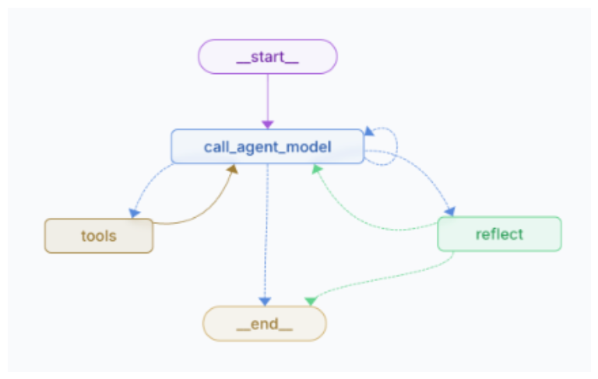
a. Arch. of Research Agent and Resource Agent
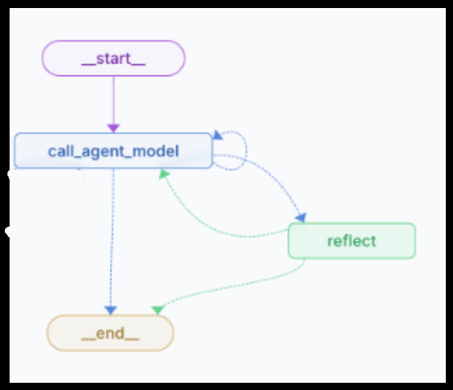
b. Arch. of Use Case Generation Agent
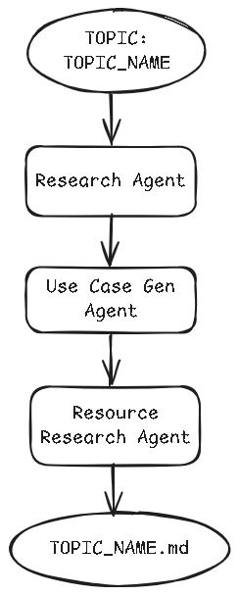
c. Orchestration/Flow of the agents
Arrows represent the directional flow of information between agents, emphasizing the system's logical and sequential structure.

Conclusion
The "Market Research & Use Case Generation Agent" showcases a well-structured multi-agent architecture tailored for the complex task of analyzing industries and generating actionable AI and GenAI solutions. By dividing responsibilities among specialized agents and adopting a sequential workflow, the system enhances clarity, efficiency, and scalability.
This architecture enables automation of traditionally labor-intensive research processes while maintaining depth and relevance in analysis. The final output equips decision-makers with actionable insights and resources to implement AI-driven innovations.
Future enhancements could include feedback loops for refinement, integration of real-time data sources, and more advanced coordination between agents, unlocking greater adaptability and intelligence in dynamic business environments.

References
- LangGraph Documentation: https://langchain-ai.github.io/langgraph/
- Pre-built Data Enrichment Agent: https://github.com/langchain-ai/data-enrichment

